|  |  |
| --- | --- |
| **Nikon D7500 (Body Only)** Máy ảnh Nikon D7500 (Body Only) | Chính hãng VIC  Nikon D7500 Nhập khẩu.8 Nikon D7500 Nhập khẩu.3 Nikon D7500 Nhập khẩu.7 Nikon D7500 Nhập khẩu.11 | **Featured information:**   * Sensor: APS-C * ISO range: 100 - 51200 (expandable 50 - 1640000) * Resolution: 20.9MP * Wireless connection: WiFi, bluetooth   **Price: 1100$**  **Specifications:**   * **Sensor Format:** APS-C (1.5x Crop Factor) * **Resolution:** 21.51 megapixels * **Size photo:** 5568 x 3712 * **Image Proportions:** 3:2, 16:9 * **Sensor Type:** CMOS * **Image Format:** JPEG, Raw * **Anti-Vibration:** Digital * **Lens Mount:** Nikon F |

**Description:**

#### **Nikon D7500 with sturdy design**

Quite similar to many Nikon DSLR cameras, the D7500 is also designed with a monocoque carbon fiber shell with good bearing capacity, working effectively in many different environmental conditions, without making the camera feel uncomfortable. heavy to hold

#### **Stylish Design**

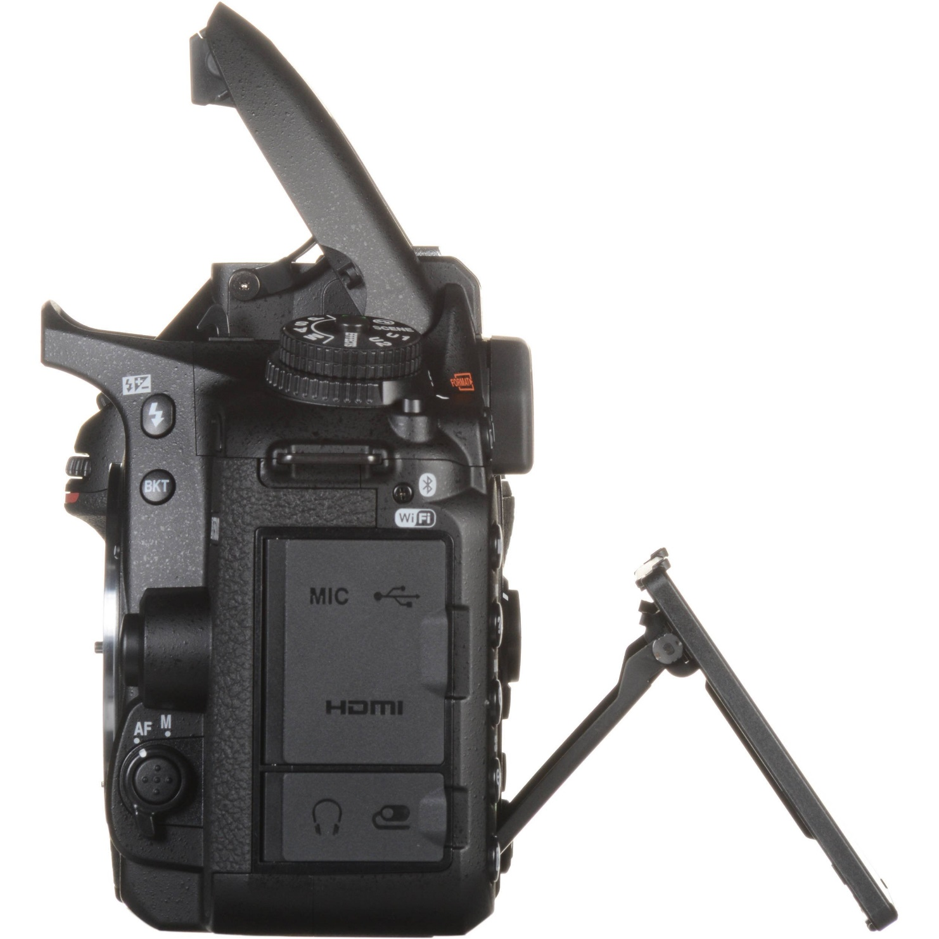

Similar to the D500, the Nikon D7500 also uses the same 20.9MP DX CMOS sensor and EXPEED 5 image processor for sensitive processing and realistic images. The camera's ISO range is from 100 - 51200 and can be expanded to 50 - 1640000 to help handle light best in many different conditions.